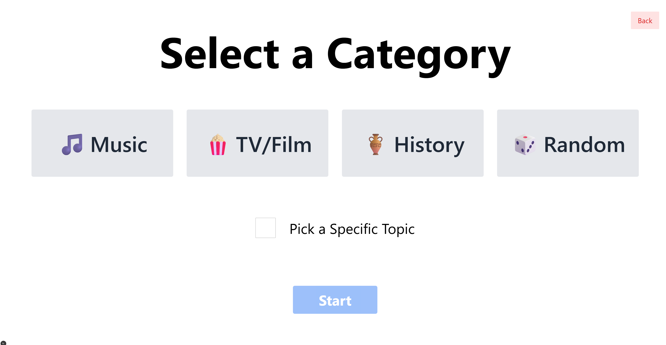

Party Mode Style Guide
All measurements use Tailwind with viewport-relative (vw) sizing and clamps to maintain legibility across devices.

1. Layout Container
<div className="min-h-screen p-[3vw] relative flex flex-col items-center"> … </div>
- min-h-screen ensures full-viewport height
- p-[3vw] dynamic padding around all sides
- relative flex flex-col items-center centers content vertically and horizontally

2. Back Button
<button
onClick={() => setStep("names")}
className="absolute top-[2vw] right-[2vw] px-[1vw] py-[.5vw] bg-red-100 text-red-600 rounded text-[clamp(1rem,6vw,3rem)]"
>
Back
</button>
- Positioned: absolute top-[2vw] right-[2vw]
- Size: px-[1vw] py-[.5vw]
- Colors: bg-red-100 default, text text-red-600
- Typography: text-[clamp(1rem,6vw,3rem)]

3. Title
<h1 className="text-[clamp(2rem,8vw,18rem)] font-bold mb-[4vw]">
Select a Category
</h1>
- Font size: text-[clamp(2rem,8vw,18rem)]
- Weight: font-bold
- Margin bottom: mb-[4vw]

4. Category Buttons
<div className="flex flex-nowrap justify-center gap-[2vw] mb-[6vw] overflow-x-auto">
{CATS.map(cat => (
<button
key={cat}
className={
`flex-shrink-0 w-[18vw] h-[10vw] rounded-xl ` +
`text-[clamp(1rem,4vw,9rem)] font-semibold transition-all outline-none focus:outline-none ` +
(selectedCategory === cat
? "bg-green-100 text-black"
: "bg-gray-200 text-gray-800 hover:bg-purple-100")
}
>
{cat}
</button>
))}
</div>
- Wrapper: flex flex-nowrap justify-center gap-[2vw] overflow-x-auto
- Button size: w-[18vw] h-[10vw] flex-shrink-0
- Font size: text-[clamp(1rem,4vw,9rem)]
- Default: bg-gray-200 text-gray-800
- Selected: bg-green-100 text-black
- Hover: hover:bg-purple-100
- Accessibility: outline-none focus:outline-none transition-all

5. Pick Subcategory Toggle
<label className="inline-flex items-center space-x-[2vw] mb-[6vw] text-[clamp(1rem,3vw,6rem)]">
<input type="checkbox" className="h-[3vw] w-[3vw]" />
<span>Pick a Specific Topic</span>
</label>
- Layout: inline-flex items-center
- Checkbox: h-[3vw] w-[3vw]
- Label font: text-[clamp(1rem,3vw,6rem)]

6. Start Button
<button
onClick={…}
disabled={!selectedCategory}
className={
`mt-[1vw] w-[12.5vw] py-[0.5vw] rounded-xl font-bold text-white transition-all outline-none focus:outline-none text-[clamp(1.5rem,4vw,6rem)] ` +
(selectedCategory
? "bg-blue-500 hover:bg-blue-700"
: "bg-blue-500 opacity-50 cursor-not-allowed")
}
>
Start
</button>
- Width: w-[12.5vw], Height via py-[0.5vw]
- Font size: text-[clamp(1.5rem,4vw,6rem)]
- Default: bg-blue-500, hover hover:bg-blue-700
- Disabled: opacity-50 cursor-not-allowed

Usage Across Screens:
- Follow these patterns for any future setup or dialog pages.
- All font-sizes, spacings, and interactive states should replicate this guide.

Last updated: based on your final category-selection pass.

